1.Write a program to read a text file and print the number of rows of data in the document.

*scala> val lines = sc.textFile("data.txt")*

*scala> lines.count()*

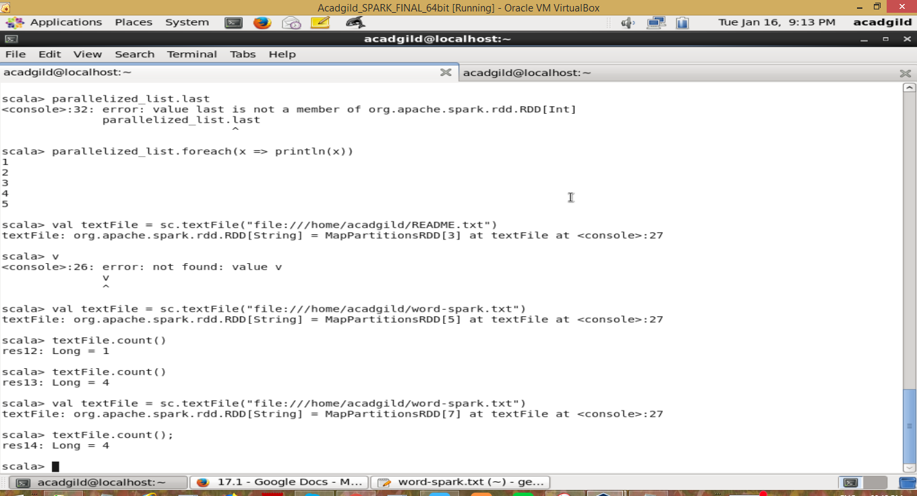

1. Write a program to read a text file and print the number of words in the document.

*val wordCounts = textFile.flatMap(line => line.split(" ")).map(word => (word, 1)).reduceByKey((a, b) => a + b)*

*wordCounts.collect().foreach(println)*

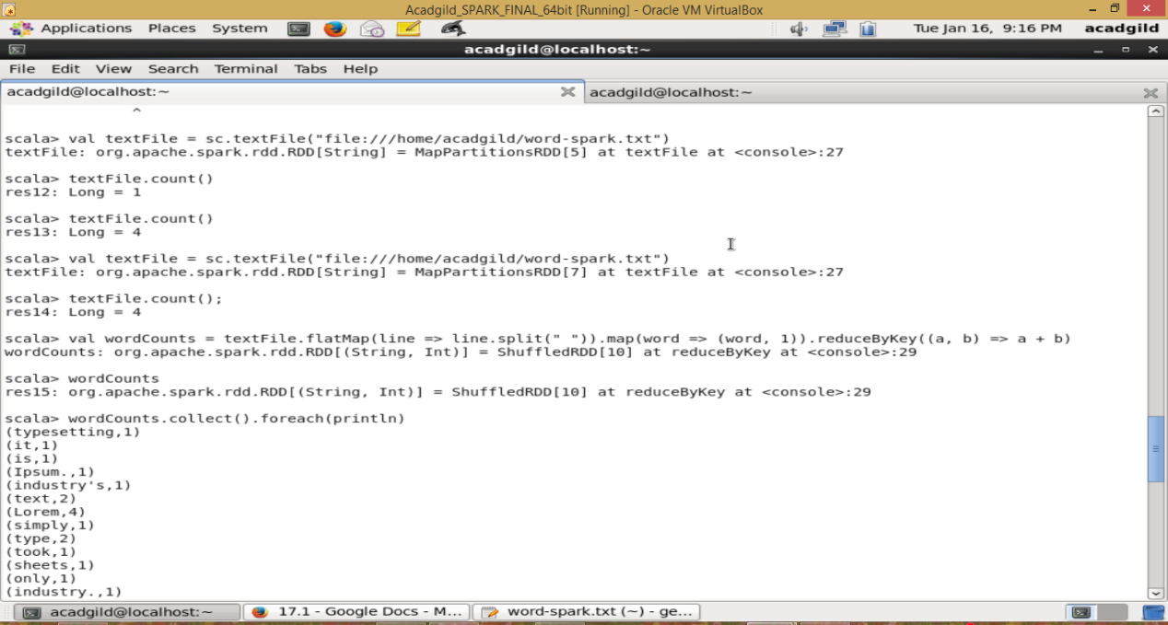

3. We have a document where the word separator is -, instead of space. Write a spark

code, to obtain the count of the total number of words present in the document.

Sample document :

This-is-my-first-assignment.

It-will-count-the-number-of-lines-in-this-document.

The-total-number-of-lines-is-3

*val textFile = sc.textFile("file:///home/acadgild/word-count2.txt")*

*val wordCounts = textFile.flatMap(line => line.split("-")).map(word => (word, 1)).reduceByKey((a, b) => a + b)*

*wordCounts.collect().foreach(println)*

